Source Code Management

Name: Anuj Preetham
Date: 31/3/2026
Slot: L25+L26

What is Git?

Git is a distributed version control system used to track changes in source code. It helps developers manage versions, collaborate with others, and revert to previous states if needed.

What is Version Control?

Version control is a system that records changes to files over time. It allows developers to track history, collaborate safely, and avoid losing work.

What is GitHub?

GitHub is a web-based platform that hosts Git repositories. It enables collaboration, sharing code, and managing projects online.

Difference Between Git and GitHub

Git is a tool; GitHub is a platform
- Git works locally; GitHub works online
- Git tracks changes; GitHub hosts repositories
- Git doesn’t require internet; GitHub does
- Git is software; GitHub is a service
Basic Git Commands
git init: Initializes a new Git repository
git status: Shows current status of files
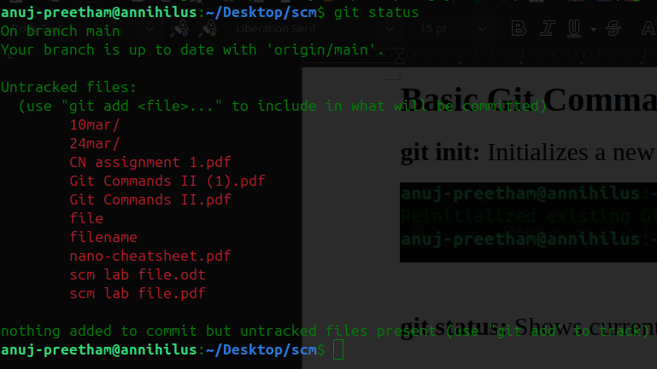
git add .: Adds all files to staging area
(no output message printed here, command executes and returns nothing to terminal prompt)
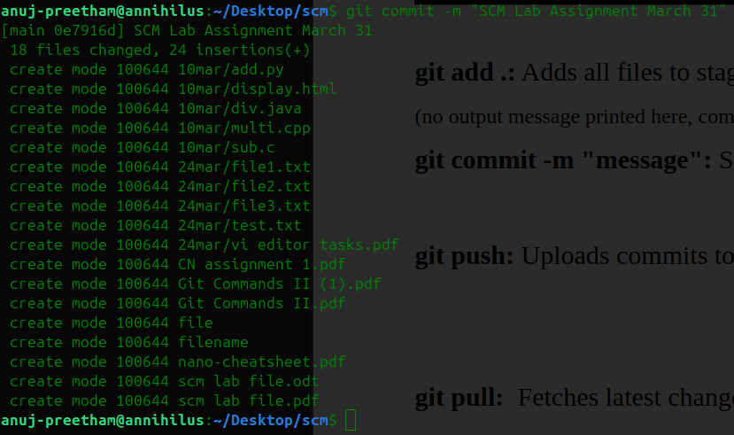
git commit -m "message": Saves changes with a message
git push: Uploads commits to GitHub
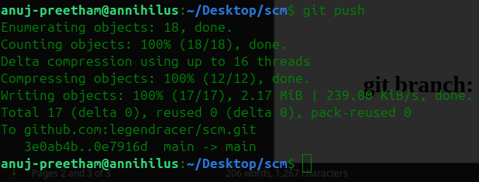
git pull: Fetches latest changes
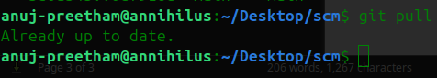

git log: Shows commit history
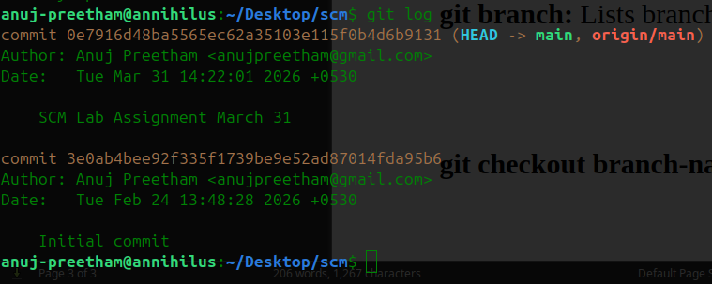
git branch: Lists branches
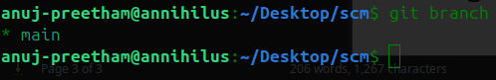
git checkout branch-name: Switches branch
